Conditional Probability with Tree Diagrams and Two-Way Tables (From Edexcel 6683)
Q1, (Jun 2005, Q7) 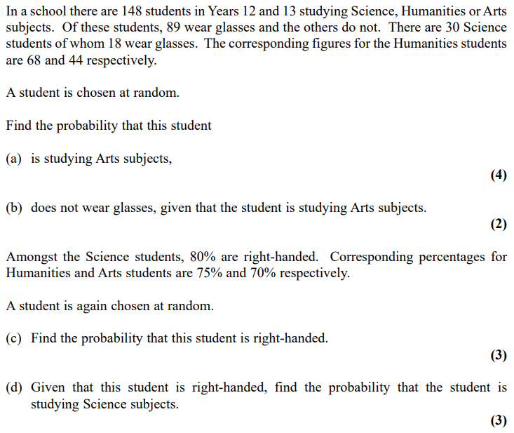
Q2, (Jan 2007, Q2) 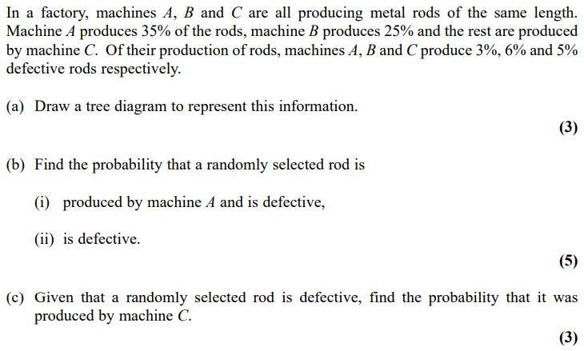
Q3, (Jun 2008, Q1) 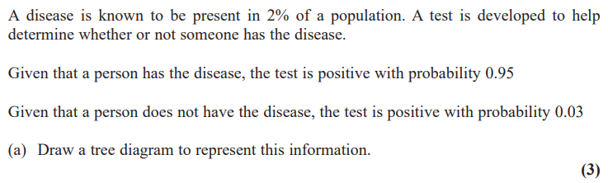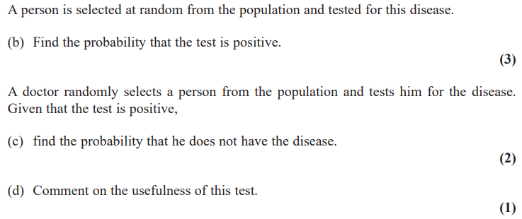
Q4, (Jan 2009, Q2) 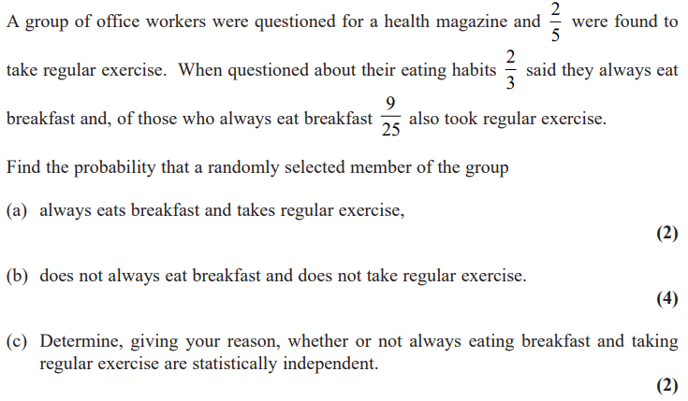
Q5, (Jun 2009, Q2) 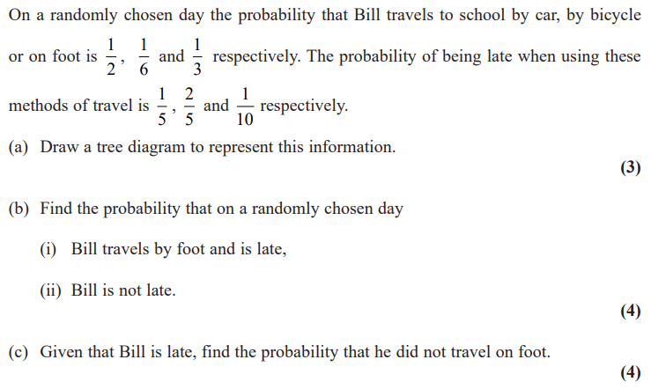
Q6, (Jun 2012, Q7) 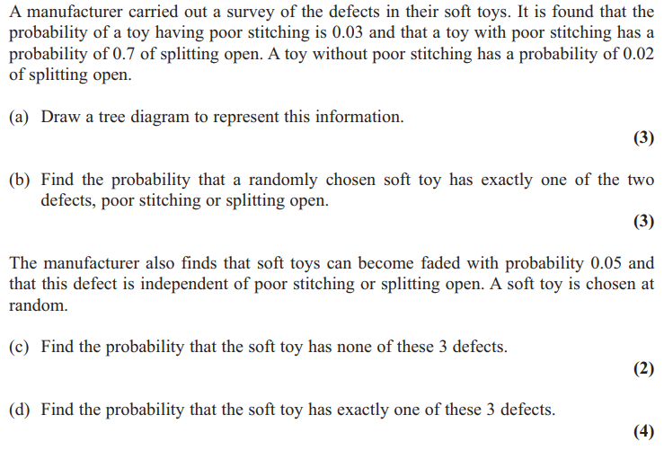

Q7, (Jan 2011, Q7) 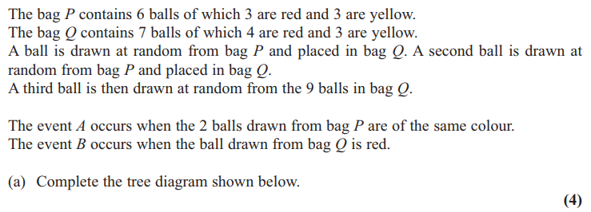
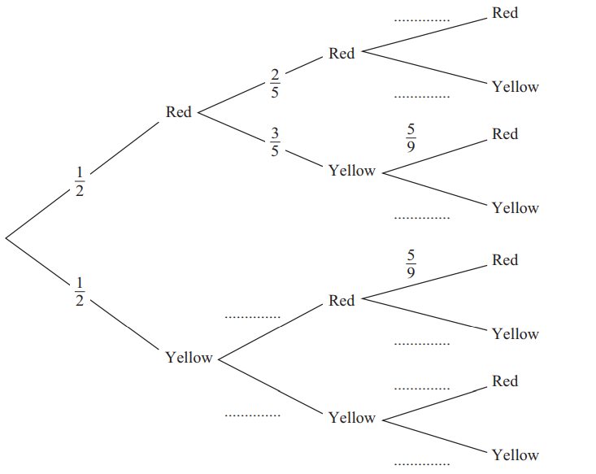
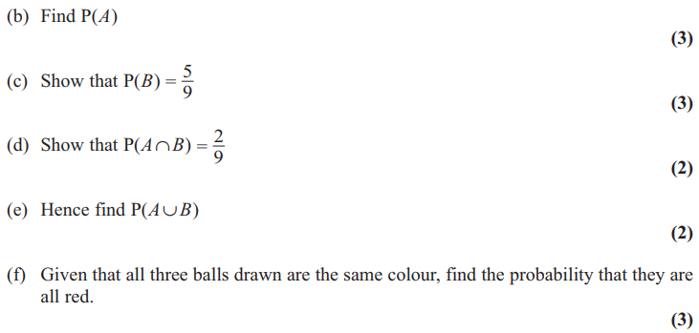
Q8, (Jun 2014, Q4) 